TDC Sample Paper Two
Physics
Written Paper Stage 2A
Question/Answer Booklet

Student Number: In figures

In words

Student name: MARKING GUIDE Teacher name: _________________

Time allowed for this paper
Reading time before commencing work: Ten minutes
Working time for paper: Two and a half hours

Material required/recommended for this paper

To be provided by the supervisor
This Question/answer booklet; Formulae and constants sheet

To be provided by the candidate
Standard items: pens, pencils, eraser or correction fluid, ruler, highlighter
Special items: scientific non-programmable calculator

Important note to candidates
No other items may be taken into the examination room. It is your responsibility to ensure that you do not have any unauthorised notes or other items of a non-personal nature in the examination room. If you have any unauthorised material with you, hand it to the supervisor before reading any further.

All calculations are to be set out in detail. Marks may be awarded for correct equations and clear setting out, even if you cannot complete the calculation. Express numerical answers to two (2) or three (3) significant figures and include units where appropriate.
Student Marks
Section |  | Maximum mark | Student mark Raw | Student Scaled Mark
Section One  15 - 20 questions | Short Answer  40% of exam | 45 |  | out of 40
Section Two  5 – 7 questions | Problem Solving  50% of exam | 45 |  | out of 50
Section Three  1 -2 questions | Comprehension  10% of exam | 20 |  | out of 10
Student Percentage
Structure of this paper

Section of exam | Suggested working time | Number of questions | Number of questions to be attempted | Marks available
Section One | 60 minutes | 16 | all | 45
Section Two | 75 minutes | 5 | all | 45
Section Three | 15 minutes | 1 | all | 20
 | 150 minutes |  | [Total marks] | 110

Instructions to candidates

- The rules for the conduct of WACE examinations are detailed in the Student Information Handbook. Sitting this examination implies that you agree to abide by these rules.
- Answer all questions in the spaces provided in this Question/Answer Booklet. Answers should be given to the appropriate number of significant figures.
- A blue or black ballpoint or ink pen should be used.
- You must be careful to confine your responses to the specific questions asked and to follow any instructions that are specific to a particular question.
- Spare pages are included at the end of this booklet. They can be used for planning your responses and/or as additional space if required to continue an answer.
  - Planning: If you use the spare pages for planning, indicate this clearly at the top of the page.
  - Continuing an answer: If you need to use the space to continue an answer, indicate in the original answer space where the answer is continued, i.e. give the page number. Fill in the number of the question(s) that you are continuing to answer at the top of the page.

Section one: Short answer 40% (45 marks)

This section has sixteen (16) questions. Answer in the spaces provided.

Suggested working time: 60 minutes.

Question 1 (4 marks)

In an experiment on scalar and vector quantities, student 1 throws a ball 3.20 m east to student 2. Student 2 then it 4.50 m west to student three. The students then measured the distance and displacement of the ball.

a. Calculate the distance the ball travelled? [1 mark]

3.20 + 4.50 = 7.70 m

Distance = 7.70 m (3sf) 1 mark

b. Draw a diagram then determine the ball’s displacement. [3 marks]

s 3.20 m east
s = 1.30 m west (3sf)

4.50 m west
Diagram = 1 mark
Value = 1 mark
Direction = 1 mark
4.50 – 3.20 = 1.30 m

Question 2 (3 marks)

Two atoms are shown below. Both have mass number 60, but atom ONE has atomic number 28 while atom TWO has atomic number 27. Use this information to fill in the table below:

atom | Nuclide of atom | Number of neutrons | Number of protons
ONE | 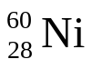 | 60-28 =  32 | 28
TWO | 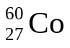 | 60-27 =  33 | 27

1 mark 1 mark 1 mark

Question 3 (2 marks)

Alan is riding his bike along the road. At one point, he needs to apply the brakes to avoid hitting a child crossing the road. On the diagram show and label all the forces acting as he brakes.

F_{R} = reaction force to ground

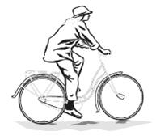

F_{m} = forward force
F_{f} = frictional force

1 mark arrow lengths
1 mark labels

F_{w} = Weight force

Question 4 (3 marks)

A passenger jet took 3.55 hours to travel from one city to another. If the jet travelled at a constant speed of 845 km h⁻¹, calculate the distance the jet travelled. Assume no air resistance.

t = 3.55 hours dist = speed x t
= 12780 s = 234.72 x 12780
Speed = 845 kmh⁻¹ = 2999750 m
= 234.72 ms⁻¹
Distance = 3.00 x 10⁶ m (3sf) 1 mark maths
1 mark conversions
1 mark answer

Question 5 (3 marks)

A ride at the park involves raising a platform, to which the riders are strapped, up a height of 30.0 m. The platform is then allowed to freefall until it is brought to a rapid stop near the ground. If the riders and platform have a mass of 2.60 x 10³ kg what would be the apparent weight of rider and platform if the platform decelerated at a rapid 12.4 m s⁻² just before it reached the ground. [3 marks]

m = 2600 kg F_{w} = m(a + g) 1 mark
a = 12.4 ms⁻² = 2600 (12.4 + 9.8) 1 mark
g = 9.8 ms⁻² = 2600 x 22.2
F_{w} = 5.77 x 10⁴ N (3sf) 1 mark

Question 6 (3 marks)

An unknown radioisotope has an activity of 15.00 g. The original activity of the sample was 8.00 kBq. If the half life of the sample was four days, calculate the activity 1.02 days later. [2 marks]

A₀ = 8.00 kBq A = A₀ ( ½ )^{n}
Half-life = 4 days = 8.00 x 0.5³
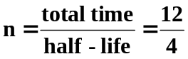 = 8.00 x 0.125
n = 3 = 1.00 kBq

activity = 1.00 kBq (3sf) 1 mark ‘n’ calculation
1 mark maths
1 mark answer

Question 7 (3 marks)

Identify “X” in each of the following equations and place its symbol in the brackets to the right of the equation. Name what is produce and if a type of radiation, name the radiation not the particle.

a. 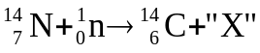 [ 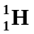 ] proton 1 mark

b. 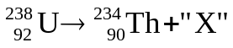 [ 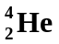 ] alpha particle 1 mark

c. 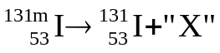 [ 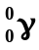 ] gamma 1 mark

(note: m denotes in excited state)

Question 8 (1 marks)

Which of the following would you choose to illustrate Newton’s first law of motion?
I A piece of stone tied to a cord is whirled in a circle. When the cord suddenly breaks, the stone flies off tangentially.
II An object falling freely has a uniform acceleration.
III The passengers in a bus lean forward when the driver applies the brakes.

A. I only
B. II only
C. III only
D. I and III only
E. All of them. Answer: D 1 mark

Question 9 (1 mark)

A student put a hot piece of toast on a cool, dry plate and then lifted it off. She saw drops of water on the plate in the area that had been covered by the toast. She thought that the water came from moisture, evaporated from the toast, which had condensed on the plate.

Which one of the following would help the student by supporting or rejecting her hypothesis? Only one answer is correct.

- Measuring the temperature of the plate before and after the toast was on it.

- Weighing the toast before and after it was on the plate.

- Measuring the temperature of the toast before and after it was on the plate.

- Weighing the plate before and after the toast was on it.

Answer: B 1 mark

Question 10 (3 marks)

A child is playing with his new remote control car. The graph below shows part of the journey.
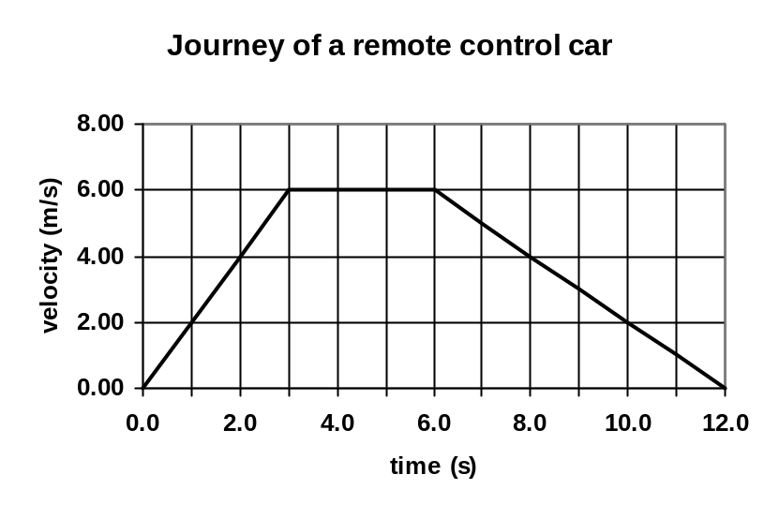
A
B
C
Calculate the displacement of the car over 12.0 seconds.

The displacement is the area under the graph for a velocity / time graph

A: 0.5 x 3 x 6 = 9 s = 45 m (2sf)

B: 3 x 6 = 18
1 mark for understanding area under graph
C: 0.5 x 6 x 6 = 18 1 mark for calculations
1 mark for answer
Total = 45
Students could do this using formulas and
values from graph so both marks on correct
choice of equations and correct answer.

Question 11 (3 marks)

While standing on a first storey balcony, a child drops a 155 g ball to the group 4.20 m below. Calculate the kinetic energy gained by the ball as it hits the ground.

E_{p} lost = E_{k} gained
mgh = E_{k} 1 mark for concept

0.155 x 9.8 x 4.2 = E_{k} 1 mark for maths
E_{k} = 6.3798 J

E_{k} = 6.38 J (3sf) 1 mark for answer

Question 12 (3 marks)

A shooter places the butt plate of a rifle against his shoulder before firing. He fires the rifle and it jerks back into his shoulder causing a bruise. By naming and using physics principles, explain why this happens.

- Newton’s third Law – for every action force there is an opposite but equal reaction force
1 mark

- Rifle is fired, gun applies force on the bullet firing bullet forward
1 mark

- At the same time, bullet applies a force on gun pushing gun backwards
1 mark

Question 13 (4 marks)

Ben is out riding his dirt bike. The bike’s engine can provide energy at the rate of 45.0 kW.

  - Calculate the amount of energy that the engine would supply to the bike in 60.0 seconds.

P = 4.5 x 10⁴ W Energy = work = P x t 1 mark
t = 60 s = 4.5 x 10⁴ x 60
= 2700000 J

Energy = 2.70 x 10⁶ J (3sf) 1 mark

  - Calculate the bike’s maximum average velocity against a total resistance force of 3.25 x 10³ N.

F = 3.25 x 10³ N 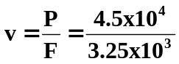 1 mark
P = 4.5 x 10⁴ W = 13.846

v = 13.8 ms⁻¹ (3sf) 1 mark

Question 14 (3 marks)

A 145.0 g cricket ball is travelling north at 29.0 m s⁻¹ when it is hit and then travels 23.0 m s⁻¹ south. Calculate the cricket ball’s change in momentum when it was hit.

OR
m = 0.145 kg Δp = m(v – u) Δp = mΔV
u = 29.0 ms⁻¹ N = 0.145 (-23 – 29) = 0.145 x 52
v = 23.0 ms⁻¹ S = 0.145 x (-52) = 7.54 Ns south
= -23 ms⁻¹ N = -7.54

OR Δp = 7.54 kgms⁻¹ (or Ns) South (3sf)
ΔV = v – u
= 23 ms⁻¹ south – 29 ms⁻¹ north correct direction 1 mark
= 23 ms⁻¹ south + 29 ms⁻¹ south values in formula 1 mark
= 52 ms⁻¹ south final answer 1 mark

If students get -0.87 Ns then give 1 mark

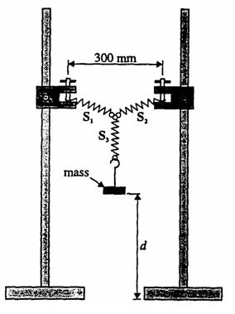
Question 15 (3 marks)

You can calculate the spring constant for a spring in a school laboratory by placing a mass on a spring in a similar set-up to that shown.

The mass can then be oscillated and the time for 10 oscillations taken. After repeating the trial, more mass is added and then the experiment is repeated. The spring constant, k, can then be calculated using the relationship.

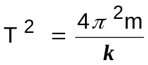

A group of students completed the experiment using the equipment set up similar to that shown. They took the appropriate measurements, recorded them and produced the graph below.
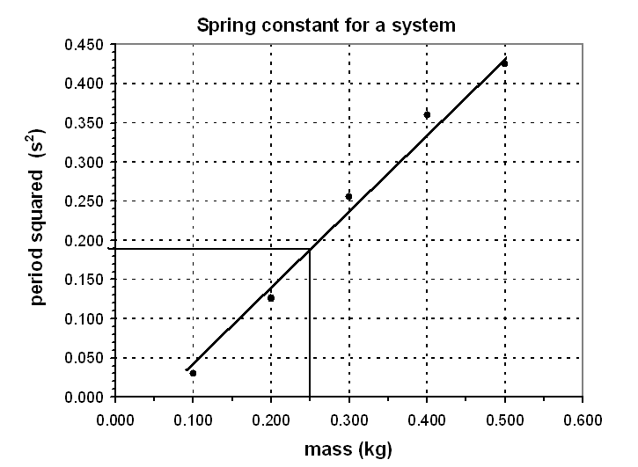
Use your own judgement on line of best fit.

1 mark

a. Complete the graph by drawing a line of best fit.

b. Calculate the period for a mass of 0.25 kg?

For 0.25 kg, T² = 0.19 (from graph) reading of ≈ 19 1 mark

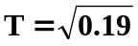

T = 0.44 s (3sf) correct answer 1 mark

should only be 2 significant figures in answer

Question 16 (5 marks)

After an animal dies it no longer takes in Carbon-14, so that the ratio of C-14 (radioactive) to C-12 (not radioactive) gradually decreases. C-14 undergoes β-decay and has a half-life of about 5730 years. The decay rate of C-14 in a living animal is around 15 decays/minute per gram of carbon. An archaeologists finds what he thinks is a dinosaur bone. The bone has a mass of 425 g of carbon. The β-decay rate from the whole bone is 50 decays/minute. What is the approximate age of the bone and based on this information, do you think the archaeologist has a dinosaur bone (dinosaurs died out about 65 million years ago)?

Living

15 x 425
= 6375 decays/min 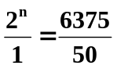 1 mark
2^{n} = 127.5
Dead 2^{n} ≈ 128

= 50 decays/min n = 7 (note: while many students don’t have the maths to
handle 2^{n} = 128, a simple trial and error approach will find the result reasonably quickly and this is intended as an A level question)
1 mark
A_{o} = 6375 1 mark
A = 50 total time = n x half-life
= 7 x 5730
Half-life = 5730 yrs = 40 110 years 1 mark

So no, not a dinosaur bone 1 mark

Section two: Problem-solving 50% (45 marks)

This section has five (5) questions. Answer in the spaces provided.

Suggested working time: 75 minutes.

Question 17 (9 marks)

A cricket ball with a mass of 160.0 g is travelling horizontally with a velocity of 28.0 m s⁻¹ when it strikes another player’s helmet. The ball is brought to rest in 0.500 x 10⁻³ s.

  - Determine the total impulse the ball delivers to the helmet? (2 marks)

m = 0.16 kg Impulse = Ft = m(v – u)
u = 28.0 m s⁻¹ = 0.16 x (0 – 28) 1 mark
= -4.48 Ns
t = 0.5 x 10⁻³ s
v = 0 Impulse = 4.48 Ns in opposite direction to initial motion. 1 mark

  - Calculate the ball’s acceleration on hitting the helmet? (2 marks)

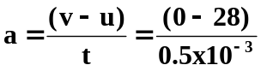 1 mark
a = -56000

a = -5.60 x 10⁴ ms⁻² (3sf) 1 mark

  - Calculate the average force the ball exerts on the helmet? (2 marks)

F = ma
= 0.160 x -56000 1 mark
F = -8960 N

F = 8.96 x 10³ N in opposite direction to initial motion. 1 mark

  - Determine the work done on the ball by the helmet to bring it to a halt? (3 marks)

u = 28 ms⁻¹ v² = u² + 2as
v = o 0 = 28² + (2 x -5600 x s) 1 mark
0 = 784 – 112000s
s = 7.0 x 10⁻³ m 1 mark

W = Fs
= 8960 x 7.0 x 10⁻³
W = 62.7 J (3sf) 1 mark
Question 18 (6 marks)

The diagram below shows the merging lane of the on-ramp of a busy freeway. A set of traffic lights is installed at X, 4.00 x 10² m from Y where the cars merge into the traffic flow. The vehicles on the busy freeway are travelling at a constant speed of 90.0 km h^{–1}. When car A, a distance d along the road from point Y, is at the position shown, the traffic light at X changes to green. Car B, at the traffic light, is then expected to uniformly accelerate to 90.0 km h^{–1} at Y and merge into traffic beside car A. Calculate the distance d. (You must show your working.)
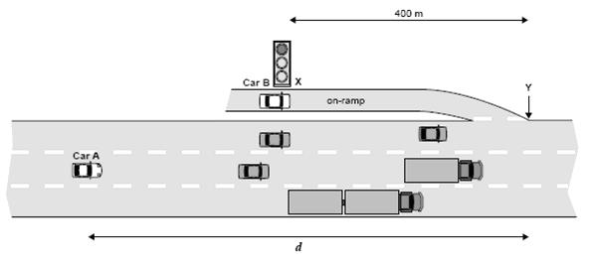

For the cars to merge together, their times must be the same.

Car B (accelerating)
u = 0 v² = u² + 2as
v = 25 ms⁻¹ 25² = 2 x a x 400 1 mark
s = 400 m 625 = 800 a
v = 90 kmh⁻¹
v = 25 ms⁻¹
a = 0.78125 ms⁻² 1 mark

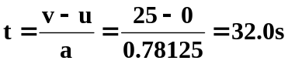 2 marks

Car A (constant vel)
V = 25 ms⁻¹ s = vt
t = same as B = 32.0 s = 25 x 32 1 mars
= 800 m

Distance = 800 m (1sf) 1 mark

Question 19 (9 marks)

A remote control car moves along a straight line. Its displacement from the starting point is shown as a function of time.
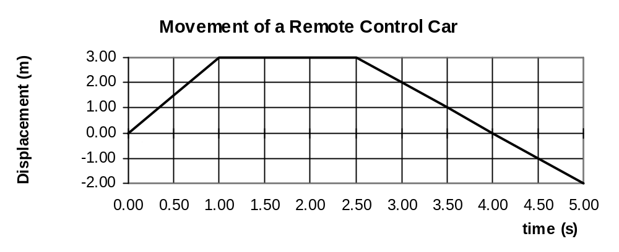
- Determine the displacement of the object at 5.00 s?

s = -2.00 m OR 2.00 m in opposite direction to start 1 mark

- Which section or sections of the graph represents a constant velocity of 3.00 ms⁻¹? You must include calculations to justify your answer.

Constant is AB or CD gradient = velocity must have some working for 2 marks
AB = 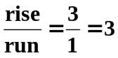ms⁻¹ CD= 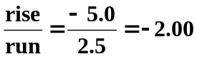 ms⁻¹ so AB 2 mark
(1 mark) (1 mark)

- Which section of the graph represents the object at rest?

BC 1 mark

- Determine the velocity for section C-D?

Again, velocity = gradient = 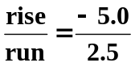 1 mark
Velocity = -2.00 ms⁻¹ 1 mark

- Determine the time elapsed before the car returned to its starting point?

Reading of graph: t = 4.00 s 1 mark

f. Sketch a velocity/time graph of the journey.

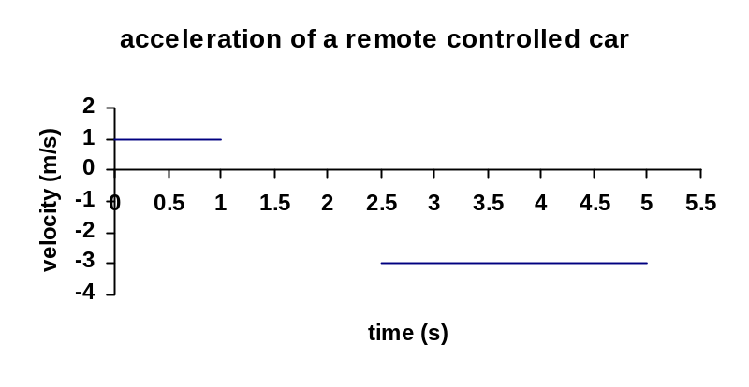

2 mark

Question 20 (12 marks)
Within a nuclear power plant, uranium-235 can undergo fission according to the equation.

- Calculate the energy in joules that would be released from the complete fission of one uranium atom.

m_{d} = (1.00867 + 235.04393) – (140.91441 + 91.92616 + (3 x 1.00867))
= 236.0526 – 235.86658
= 0.186024 u 1 mark
= 0.186024 x 1.6606 x 10⁻²⁷
= 3.089 x 10⁻²⁸ kg 1 mark

E = m_{d} x c²
= 3.089 x 10⁻²⁸ x (3 x 10⁸)² 1 mark
= 2.7801 x 10⁻¹¹ J

Energy = 2.78 x 10⁻¹¹ J (3sf) 1 mark

- Determine the amount of energy released per kilogram of uranium atoms?

3.089 x 10⁻²⁸ kg = 2.78 x 10⁻¹¹ J
1.00 kg = energy

Energy = 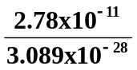 1 mark
Energy = 9.00 x 10¹⁶ J (3sf) 1 mark

- Another nuclear reaction is that which occurs in the Sun.
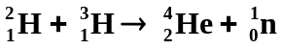
Calculate the energy released in MeV for one such reaction.

M_{d} = (2.01355 + 3.01605) – (4.00260 + 1.00867) 1 mark
= 5.0296 - 5.01127
= 0.01833 u 1 mark

Now 1u = 931 MeV

Energy = 931 x 0.01833
= 17.065

Energy = 17.1 MeV (3sf) 1 mark

- Safety is a big issue in nuclear power stations and all employees must wear a film badges that registers the amount of radiation they have received each month. Film badges have a photographic film enclosed within an opaque plastic case that is sensitive to both gamma and beta radiation. While the amount of beta radiation they receive is not a problem, the amount of gamma is and a film badge must be able to show the difference. Using your understanding of the characteristics of beta and gamma radiation, explain how the film badge could be made to show the difference between the amount of beta and gamma radiation the employee had received that month.

- Beta radiation will go through the plastic but not thin aluminium sheeting. Gamma radiation will pass through bother the plastic and aluminium sheeting. 1 mark

- By having half the film covered in aluminium sheeting, all the film will be exposed to gamma but only half to beta. 1 mark

- By comparing the different amount of exposure to each other and to set standard films it is possible to determine the exposure to beta and gamma radiation. 1 mark
Question 21 (8 marks)

An industrial physicist accidentally swallows a radioisotope with an activity of 10.0 kBq. The material swallowed has a very long half-life. You can assume therefore that the activity will not change appreciably during the physicist’s lifetime. Each decay of the isotope releases 1.60 x 10⁻¹³ J of energy into his body and that the radioisotope is not eliminated from the body.

a. Calculate the amount of energy absorbed in one year. (1 year = 365 days)
(If you are unable to do this part, use the value 0.100 J to continue this question.)

Energy = activity x energy per decay x total time 1 mark

Total time 10 x 10³ x 1.6 x 10⁻¹³ x 31536000 1 mark
= 60 x 60 x 24 x 365 = 5.04576 x 10⁻²
= 31536000 s

Energy = 5.50 x 10⁻² J (3sf) 1 mark

- If the physicist has a mass of 70.0 kg, calculate the absorbed dose in one year.

Absorbed dose = 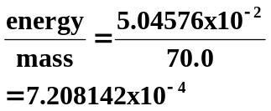 1 mark
If using 0.100 J
AD = 0.1 / 70
AD = 1.43 x 10⁻³ Gy

Absorbed dose = 7.21 x 10⁻⁴ Gy (3sf) 1 mark

Some types of absorbed radiation are potentially more damaging than others. For example, a particular absorbed dose of α radiation is much more damaging to the cells of the body than the same dose of β or γ radiation. To take this into account the absorbed dose is multiplied by an extra weighting called the Quality Factor (QF). Assuming that the ingested radioisotope is an alpha emitter. (QF = 20),

- What is the dose equivalent absorbed per year?
If using 0.100 J
DE = 1.43 x 10⁻³ x 20
= 2.86 x 10⁻² Sv
Dose equivalent = 20 x 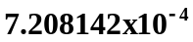 1 mark
= 0.0144
Dose equivalent = 1.44 x 10⁻² Sv (3sf) 1 mark

- Should the physicist be concerned about this yearly radiation exposure? Explain.
No. This is a very low dose and would have no observable effects. 1 mark

Section three: Comprehension 10% (20 marks)

This section has one (1) question. Answer in the spaces provided.

Suggested working time: 20 minutes.

Question 22 (20 marks)

In a Physics investigation, a group of students measures the time (t) for a trolley to roll down a 5.0 m incline starting the trolley from rest. The slope is determined by raising one end of the plank by distance H. After repeating the measurement four times, the students then increases the slope of the incline, and repeats the timing procedure for the trolley to cover the same distance. The students repeats the exercise for four other slopes, the results of which are recorded in the table below.
1 mark
for discarded values

2 mark
for averages –

1 mark
Averages one decimal place.
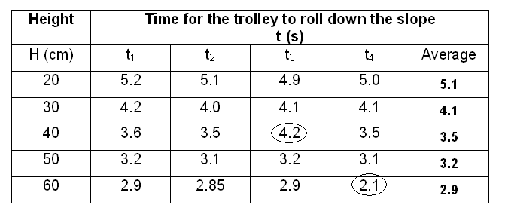

State the independent and dependent variables for this experiment.
  - Independent: Height end of plank raised to 1 mark
  - Dependent: time to run down plank 1 mark

- List TWO control variables to make it a fair test.
Some possible answers are:
    - Same trolley used
    - Same plank two appropriate variables - 2 marks
    - Same person timing
    - Same person releasing trolley

- Explain why the students repeated the trials four times before changing the height.
This makes the investigation more accurate by
1. reducing human error 1 mark

2. reducing the uncertainty in the measurements. 1 mark

Now regarding the data:

Circle any of the results you would disregard when finding the average of the results.
See table on previous page.

- Explain why you would disregard these results and if it is acceptable to do so.
These two results fall way outside the other results for that trial. 1 mark
It is acceptable to do so 1 mark
as they would have artificially raised or lowered the average for that set of results. 1 mark
Would have been better to have repeated those trials.

- Complete the table above by calculating the averages.
See table on previous page.

- Plot a graph of H against t on the graph paper on page 21.
- Write a conclusion for this investigation based on the data collected and the graph.
As the height of the end of the plank increases, the time decreases. 1 mark
The results also show that as the height is increased, the time is decreasing at a quicker rate. 1 mark

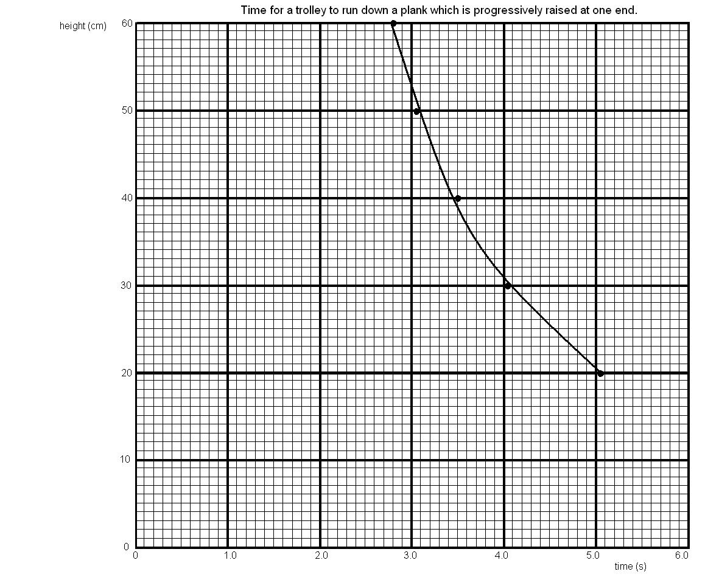

5 Marks
- all axes labelled correctly
- correct units on axes titles
- points plotted correctly
- line of best fit
- graph title

END OF EXAMINATION

_____________________________________________________________________________________________________________________________________________________________________________________________________________________________________________________________________________________________________________________________________________________________________________________________________________________
_____________________________________________________________________________________________________________________________________________________________________________________________________________________________________________________________________________________________________________________________________________________________________________________________________________________
_____________________________________________________________________________________________________________________________________________________________________________________________________________________________________________________________________________________________________________________________________________________________________________________________________________________
_____________________________________________________________________________________________________________________________________________________________________________________________________________________________________________________________________________________________________________________________________________________________________________________________________________________
_____________________________________________________________________________________________________________________________________________________________________________________________________________________________________________________________________________________________________________________________________________________________________________________________________________________
_____________________________________________________________________________________________________________________________________________________________________________________________________________________________________________________________________________________________________________________________________________________________________________________________________________________
_____________________________________________________________________________________________________________________________________________________________________________________________________________________________________________________________________________________________________________________________________________________________________________________________________________________
_____________________________________________________________________________________________________________________________________________________________________________________________________________________________________________________________________________________________________________________________________________________________________________________________________________________
_____________________________________________________________________________________________________________________________________________________________________________________________________________________________________________________________________________________________________________________________________________________________________________________________________________________
_____________________________________________________________________________________________________________________________________________________________________________________________________________________________________________________________________________________________________________________________________________________________________________________________________________________
_____________________________________________________________________________________________________________________________________________________________________________________________________________________________________________________________________________________________________________________________________________________________________________________________________________________
__________________________________________________________________________________________________________________________________________________________________

